Family Job Tree
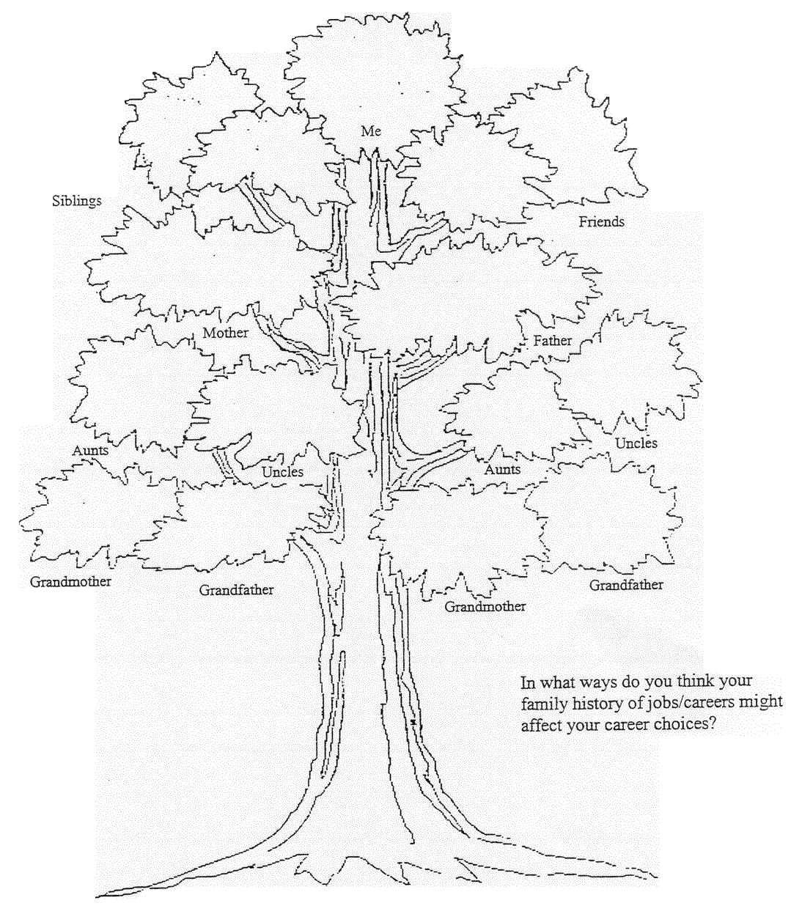

Questions – Educational Requirements

- Realizing that the term “secondary” means high school, name classes you should take in high school:

- What is Post secondary education:

- Name some post-secondary institutions in North Carolina.

- How many years of education are required for the following?

- Associate’s -
- Bachelor’s –
- Master’s –
- Doctorate –

- Name a career that would require the following degree for entry level:
  - Associate’s Degree –
  - Bachelor’s Degree –
  - Master’s Degree –
  - Doctorate Degree –

- What is certification:

What is registration:

What is licensure:

What is accreditation:

- What are CEU’s?

- What is a trend in healthcare?

- What is the benefit in hiring multi-skilled personnel?

- Name some health careers that have entrepreneurial potential.

Am I an Entrepreneur? Directions:Test your entrepreneurial quotient by circling the letter of the phrase that best describes you.

Directions: Test our entrepreneurial quotient by circling the letter of the phrase that best describes you.

1. Are you a self-starter?
a. I do things my own way. Nobody has to tell me to get going.
b. If someone gets me started, I keep going all right.
c. Easy does it, I don't put myself out until I have to.

2 How do you feel about other people?
a. I like people. I can get along with just about anybody.
b. I have plenty of friends--I don't need anyone else.
c. Most people bug me.

3. Can you lead others?
a. I can give most people to go along when I start something.
b. I can give the orders if someone tells me what we should do.
c. I let someone else get things moving. Then I go along if I feel like it

4. Can you take responsibility?
a. I like to take charge of things and see them through.
b. I'll take over if I have to, but I'd rather let someone else be responsible.
c. There's always some eager beaver around wanting to show how smart he is. I say let him.

5. Are you a good organizer?
a. I like to have a plan before I start. I'm usually the one to get things lined up when the gang wants to do something.
b. I do all right unless things get goofed up. Then I cop out.
c. You get all set and then something comes along and blows the whole bag. So just take things as they come.

6. Are you a good worker?
a. I can keep going as long as I need to. I don't mind working hard for something I want.
b. I'll work hard for a while, but when I've had enough, that's it, man!
c. I can't see that hard work gets you anywhere.

7. Can you make decisions?
a. I can make up my mind in a hurry if I have to. It usually turns out okay, too.
b. I can if I have plenty of time. If I have to make up my mind fast, I think later I should have decided the other way.
c. I don't like to be the one who has to decide things. I'd probably blow it.

8. Can people trust what you say?
a. You bet they can. I don't say things I don't mean.
b. I try to be on the level most of the time, but sometimes I just say what's easiest.
c. What's the sweat if the other person doesn't know the difference?

9. Can you stick with it?
a. If I make up my mind to do something, I don't let anything stop me.
b. I usually finish what I start--if it doesn't get fouled up.
c. If it doesn't go right to start with, I turn off. Why beat your brains out?

10. How good is your health?
a. I never run down.
b. I have enough energy for most things I do.
c. I run out of gas sooner than most of my friends.

Now tally your answers. If you circled mostly "a" responses, you probably have what it takes to run a business. If not, you're likely to have more trouble than you can handle by yourself. You'd better find a partner who is strong in your weak areas. If most of your responses were "c," not even a partner will be able to shore you up.

