|  |  |  |
| --- | --- | --- |
| **4.03 Leadership & Teamwork** name\_\_\_\_\_\_\_\_\_\_\_\_ | | |
| **Teamwork is:** |  | |
| **Teams:** |  | |
| **Example of medical office health care team:** | |  |
| **Leadership is:** |  | |
| **A Leader is:** |  | |
| **Leader’s Responsibility:** | | |
|  | | |
|  | | |
|  | | |
| Ex: | | |
|  | | |
| Ex: | | |
| **Methods to Develop Good Interpersonal Relationships include:** | | |
|  | | |
|  | | |
| Ex: | | |
| Ex: | | |
| Ex:  Ex: | | |
|  | | |
|  | | |
| Ex: | | |
|  | | |
|  | | |
|  | | |
|  | | |
| Ex: | | |

|  |  |
| --- | --- |
| **Professional Leadership is:**  **Example:** |  |
| **Professional Leadership Characteristics:** | |
|  | |
|  | |
|  | |
|  | |
|  | |
|  | |
|  | |
|  | |
| **Types of Leaders:** | |
| Democratic Leader: |  |
| Laissez-faire Leader: |  |
| Autocratic Leader: |  |

**Classification of Leaders**

Identify each leader or description as:

**D = Democratic L = Laissez-faire A = Autocratic**

\_\_\_\_\_ 1. An informal type of leader.

PE01753_[1]

\_\_\_\_\_ 2.

\_\_\_\_\_ 3. Encourages the participation of all individuals in the decision-making process.

Image of today's
outrage

\_\_\_\_\_ 4.

\_\_\_\_\_ 5. Has a “hands-off” policy.

\_\_\_\_\_ 6. Strives for minimal rules and regulations and allows individuals in the group to function in an independent manner.

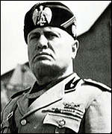

\_\_\_\_\_ 7.

\_\_\_\_\_ 8. Individuals follow this type of leader because they fear punishment or because of extreme loyalty.

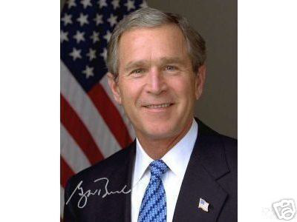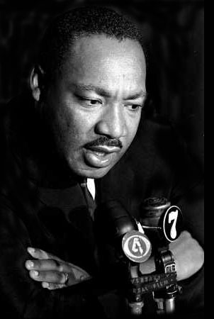

\_\_\_\_\_ 9. \_\_\_\_\_ 10.

**Group Activity Evaluation Form**

BD19669_[1]

Read each statement and evaluate your group as follows: 4 = Excellent

3 = Good

2 = Fair

1 = Needs improvement

|  |  |  |
| --- | --- | --- |
| **Leadership Criteria** | **Score** | **Comments** |
| 1. Group members respect the rights, dignity, opinions and abilities of others. |  |  |
| 2. Group members understand the principles of democracy. |  |  |
| 3. Members work as a group and guide the group towards the goal. |  |  |
| 4. Individuals in the group understand their own strengths and weaknesses. |  |  |
| 5. Group members display self-confidence and are willing to take a stand. |  |  |
| 6. Group members communicate effectively. |  |  |
| 7. Group members show initiative and a willingness to work. |  |  |
| 8. The group completed the task in the time allowed. |  |  |
| 9. Group members show optimism. |  |  |
| 10. Group members are open-minded and willing to compromise. |  |  |
| 11. Groups members praise and gave credit to others. |  |  |
| 12. Group members are dedicated to high standards. |  |  |

If you could repeat the activity, what would your group do differently?